2017 Designathon
Visability Guidelines
for non-profit participants

February 24 & 25, 2017
Begins at 6 p.m. on 2/24/17

Thank you for participating in the 9th annual Designathon. Pennsylvania College of Art & Design looks forward to the shared opportunity to work with your organization and to help you with your design needs.

When we need you:
- We will need your organization to send a representative or representatives to PCA&D on Friday, February 24, 6:00 p.m. to meet with a student group to pitch/discuss the specifics of your project. We ask each representative(s) to give a brief presentation telling everyone about your organization and the design needs that you are requesting of the Designathon participants.
- The same representative(s) will need to return on Saturday, February 25, 6:00 p.m. for the student group presentation.
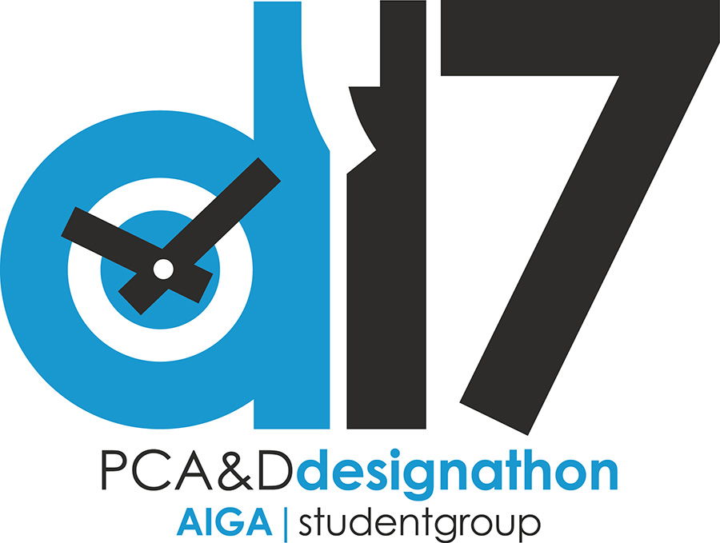
What else we need:
- We will need all required logos, graphics, photos, word documents, etc. provided in electronic format. We can accept these items on a CD/flash drive the night of the event during your pitch or you may email them to me ahead of time.
- A friendly reminder... these are starving artists hard at work for your organization. Any potluck dinners, pizza, sandwiches, snacks, fruit or vegetable trays, breakfast items, drinks, etc. provided for at least 33 students and faculty would be greatly appreciated.

Visability: In order to participate in PCA&D’s annual Designathon, your organization has agreed to complete the following visibility activities:

Please note: When you use PCA&D’s student work in your marketing pieces, include a credit line. For print, the credit line would read: “John Smith ’16, Pennsylvania College of Art & Design,” or “Created by John Smith ‘16 as part of 2017 Designathon at Pennsylvania College of Art & Design.” For Web site or Facebook, use a similar credit line plus a hyperlink back to www.pcad.edu/news.

- Website: Your organization writes a mention about PCA&D and its Designathon on the home page or a logical sub-page of your Web site. Post must remain for a minimum of 30 days prior to and 30 days after the Designathon. The mention on your site or Facebook page must include the PCA&D logo and a hyperlink back to pcad.edu/news. PCA&D logo is attached. Suggested text:
  - NAME OF NON_PROFIT is excited to be chosen as a participating organization in Pennsylvania College of Art & Design’s 7th annual Designathon, which will be held on February 19 and 20, 2016. During the Designathon’s 24 hours, teams of students and faculty mentors create all-new pieces for eight non-profits non-profit. Learn more at PCAD.edu/news.

- On Facebook, post an announcement about the initiative at least once before and once after Designathon. The mentions link back to pcad.edu/news. Here are some suggestions:
  - Before: NAME OF NON_PROFIT is excited to be chosen as a participating organization in Pennsylvania College of Art & Design’s 7th annual #Designathon. #PCA&D’s students will be developing materials for our use over a 24-hour period! Thank you PCA&D! www,pcad.edu/news
  - After: Post a picture of the PCA&D team who worked on your materials, with a description of the materials they developed during the Designathon. Please include www.pcad.edu/news in your post.
  - While you are at PCA&D during the Designathon, feel free to post on your organization’s social media accounts about the Designathon, Please include www.pcad.edu/news in your post.
  - Feel free to post about the Designathon on Twitter and other social media platforms as well, if you use them.

- Your print and electronic newsletters published before and after the Designathon must include a mention about PCA&D and the event. This can be as simple as a few sentences with PCA&D’s location (Lancaster) and its Web address (www.pcad.edu). After the event, the newsletter blurb can include a photo of the design created by PCA&D students for your organization, the students’ names, PCA&D’s location (Lancaster) and its Web address (www.pcad.edu).

- Your Board of Directors: After the completion of the Designathon, an appropriate representative of your organization makes a brief mention at your next Board meeting about the Designathon and working with Pennsylvania College of Art & Design students.

  - Questions about the “Visibility Guidelines” can be directed to Kathy Smyser, director of communications at PCA&D, via email at ksmyser@pcad.edu or by phone (717) 396-7833, ext. 1017.

  - Questions about the work that the students will be doing can be addresses to Pamela S. Barby, Chair, Graphic Design - Communication Arts, p: 717.396.7833, ext. 1051 or pbarby@pcad.edu.

About Pennsylvania College of Art & Design
Pennsylvania College of Art & Design is central Pennsylvania’s only non-profit professional art college offering BFA degrees, certificates, credentials, and curricula that enable students of all ages to pursue art as their life’s work. The College’s educational philosophy of “Communication as Currency” develops artists able to create influence through the powerful combination of thinking, making, and communicating.
Founded in 1982, PCA&D is accredited by the National Association of Schools of Art and Design (NASAD) and the Middle States Commission on Higher Education (MSCHE) and is a member of the Association of Independent Colleges of Art & Design (AICAD).
PCA&D also offers credit and noncredit classes, studios and workshops for adults and youth, a professional gallery that features works by regionally- and nationally-acclaimed artists, and artist and author talks, receptions, and community-based activities with visiting artists. For more information, contact PCA&D, PO Box 59, 204 North Prince Street, Lancaster, PA 17608. (717) 396-1032, (800) 689-0379. www.pcad.edu.

